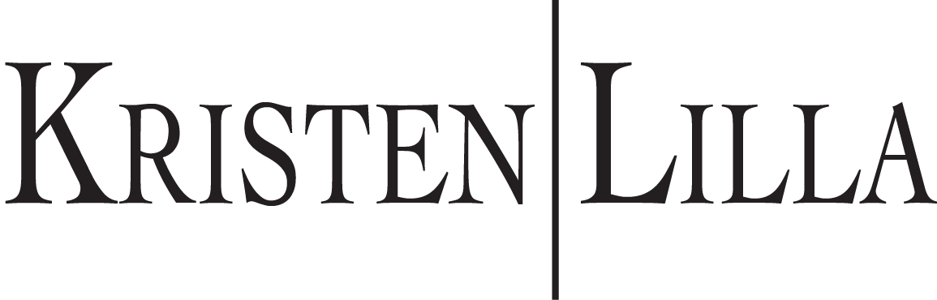
Licensed Clinical Social Worker
AASECT Certified Sex Therapist, Sex Educator, & Supervisor
P.O. Box 31490 Omaha, NE 68131 Phone- 402-201-6046
Disclosure Statement
- Degrees: Pennsylvania State University, BS Psychology; Pennsylvania State University, BS Women’s Studies; University of Denver, Master of Social Work
- Licenses: State of Iowa LICSW (#100659). State of Illinois LCSW (#149.023438). State of Nebraska LMHP (#4297), State of Nebraska CMSW (#1518). State of Wisconsin LCSW (#9705).
- Certifications: AASECT Certified Sex Therapist (CST), AASECT Certified Sexuality Educator (CSE), AASECT Certified Sex Therapy Supervisor (CSTS), AASECT Certified Sexuality Educator Supervisor (CSES)
- Licensed individuals in the field of psychotherapy are regulated. Investigations can be reached at:
- IA Dept. of Public Health 321 E. 12th Street Des Moines, IA 50319
- IL Dept. of Financial & Professional Regulation 100 West Randolph 9th Floor Chicago, IL 60601
- NE Dept. of Health & Human Services 1033 O Street, Suite 500 Lincoln NE 68508
- WI Dept. of Safety & Professional Services 4822 Madison Yards Way Madison, WI 53705
- You are entitled to receive information from your therapist about the methods of therapy, the techniques used, the duration of your therapy (if known), and the fees involved. You can seek a second opinion at any time from another therapist or choose to terminate therapy without prior notice. All methods utilize talk therapy via telehealth, and at times may include resources to utilize at-home exercises.
- The current fee structure is $230 for a 50-minute session. Insurance is not accepted and payment is required at the time of the appointment. A minimum notice of 24 hours is required to cancel/reschedule an appointment. You will be billed a fee of $115 for not giving a minimum of 24 hours notification of cancellation. This outstanding balance must be paid prior to additional services being delivered. You may be billed for non-covered and non-routine services (such as documentation, extended telephone consultation, report writing, legal reporting, testifying in court, etc), at an additional rate of $50 for each 15-minute increment.
- Please note that nudity is never permissible and should be reported. Sex therapy involves a professional relationship between you and your therapist and any nudity or sexual activity between a therapist and client is against the ethics of NASW and AASECT.
- I have read the preceding information and understand my rights as a client.
__________________________________________
Print Client Name
______________________________________________________________________________
Client/Responsible Party signature Date
If signed by Responsible party, please state relationship to client and authority to consent:__________________
______________________________________________________________________________
Therapist Signature Date

